


Stage 1: Creating qualifications

Produced by: Gary Harlock

On behalf of: Perspective Limited
The Oracle Building
Blythe Valley Business Park
Shirley, Solihull
B90 8AD

20th September 2010

Log In
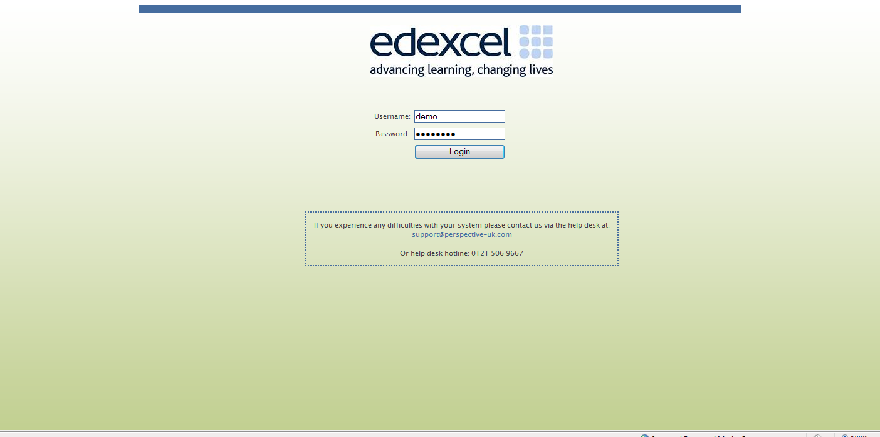

Home page
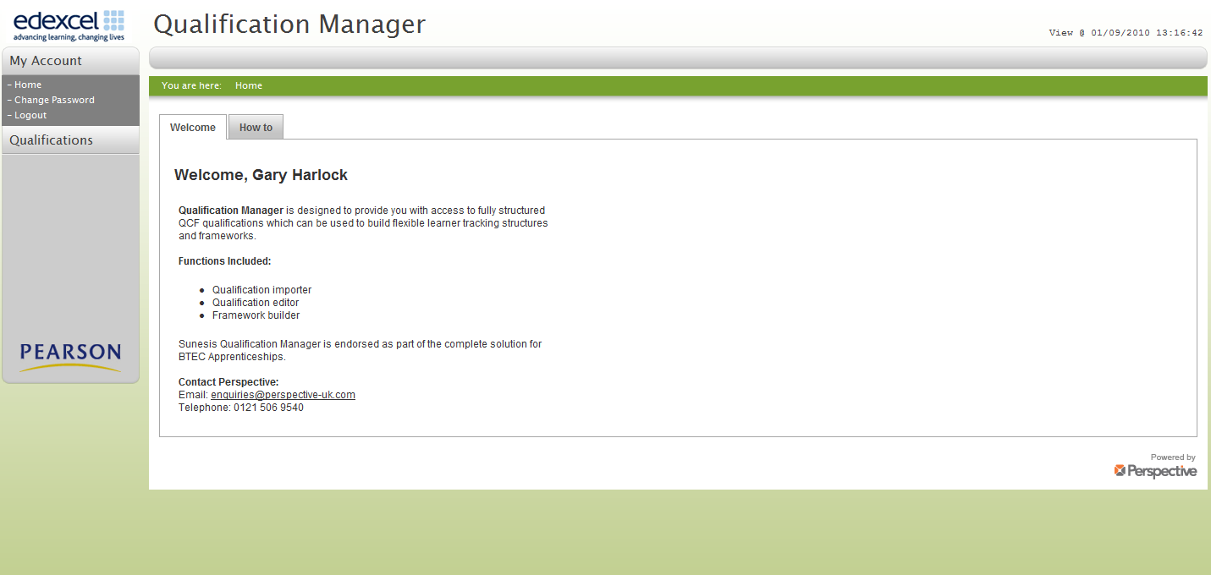

Add new Qualifications
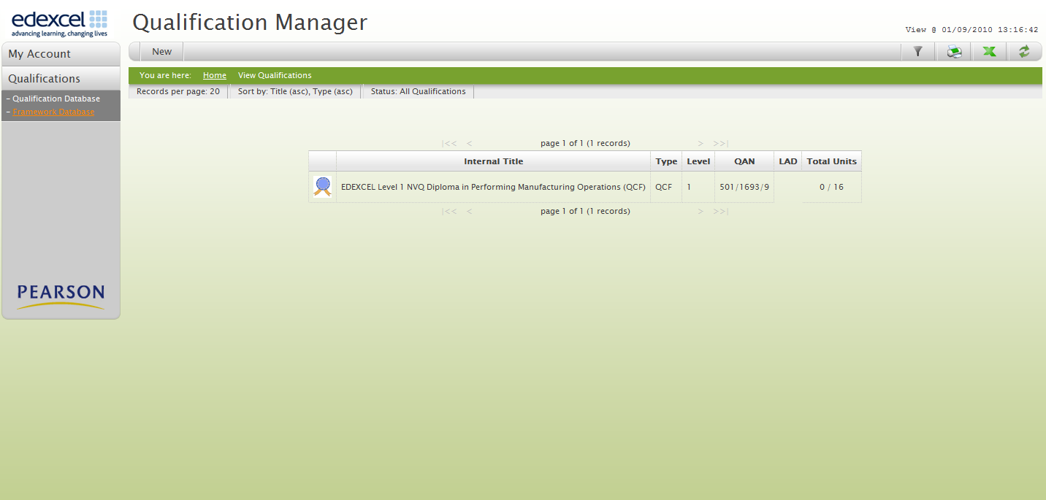
1: Click Qualification

2: Click New

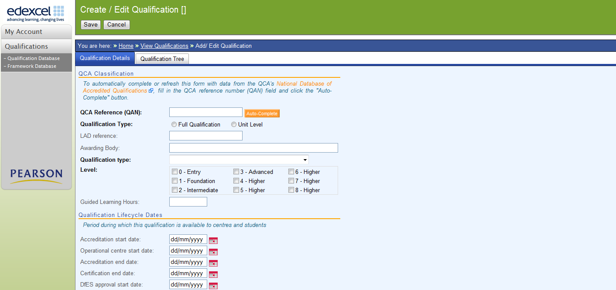
3: Click Qualification tab

4: Click NDAQ hyperlink

Link to NDAQ
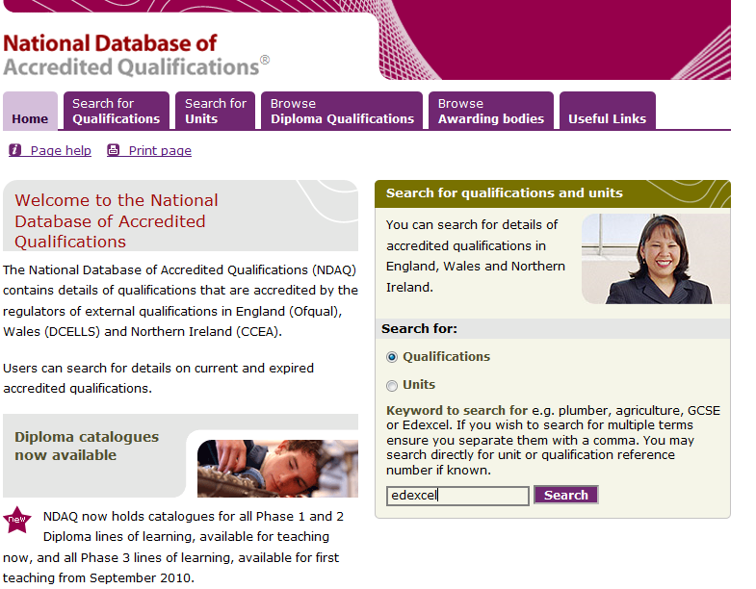

5: Click Search Qualification

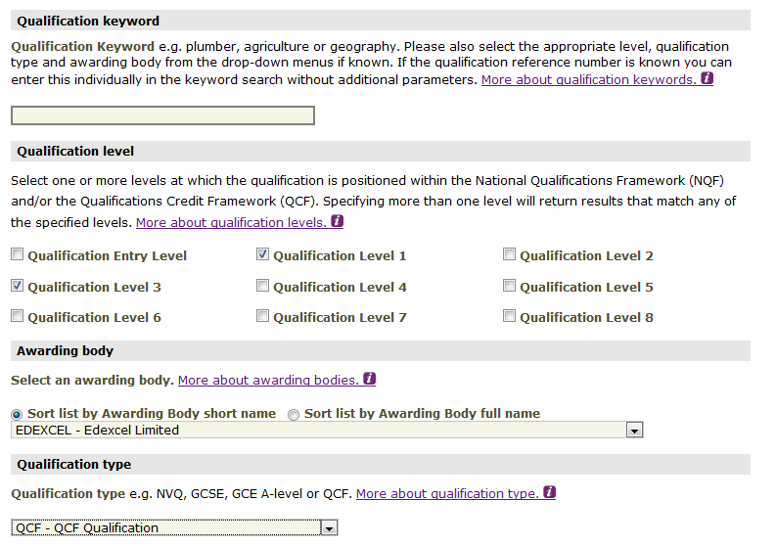

6: Add search criteria

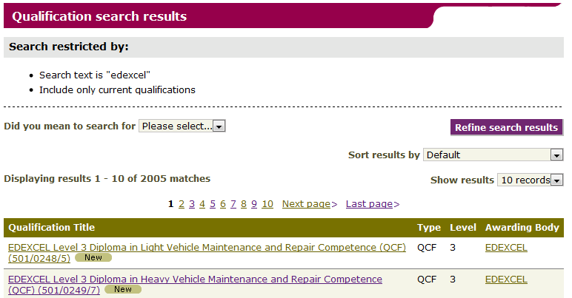
7: Identify Qualification
8: Double Click

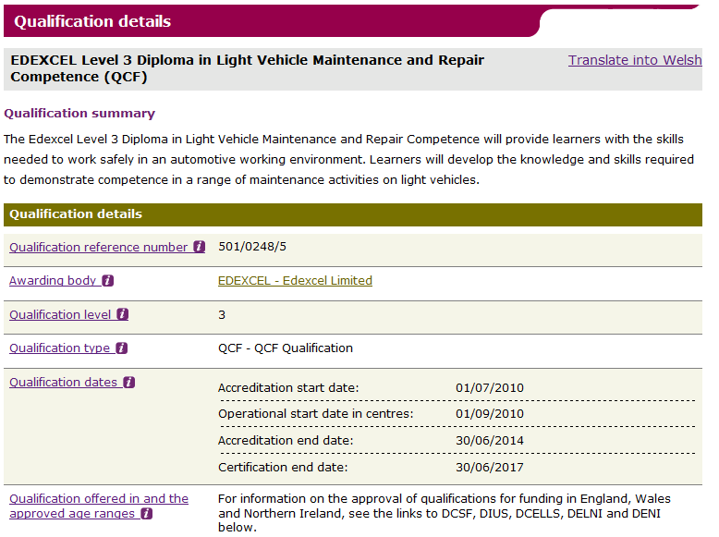
9: Copy qualification number

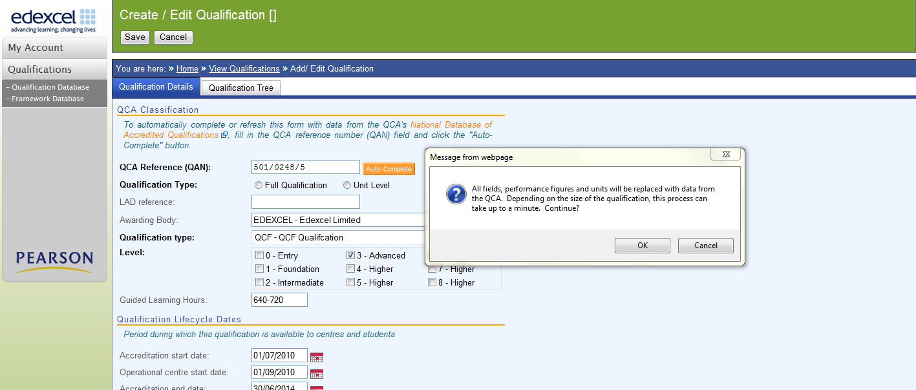
10: Paste number to box
11: Click Auto-complete and OK
12: The fields are populated
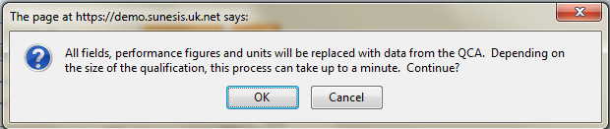

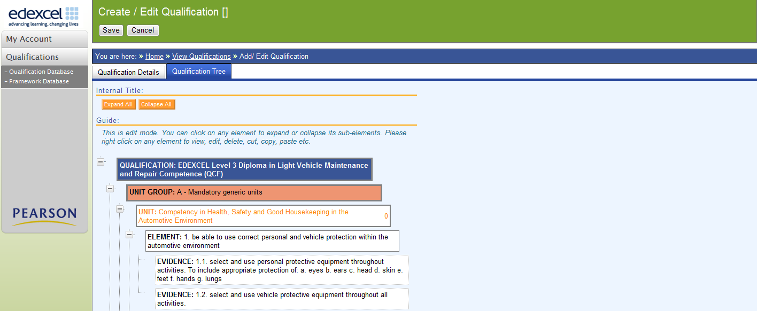
13: The qualification structure is populated with Units, Elements and Evidence

14: Save qualification

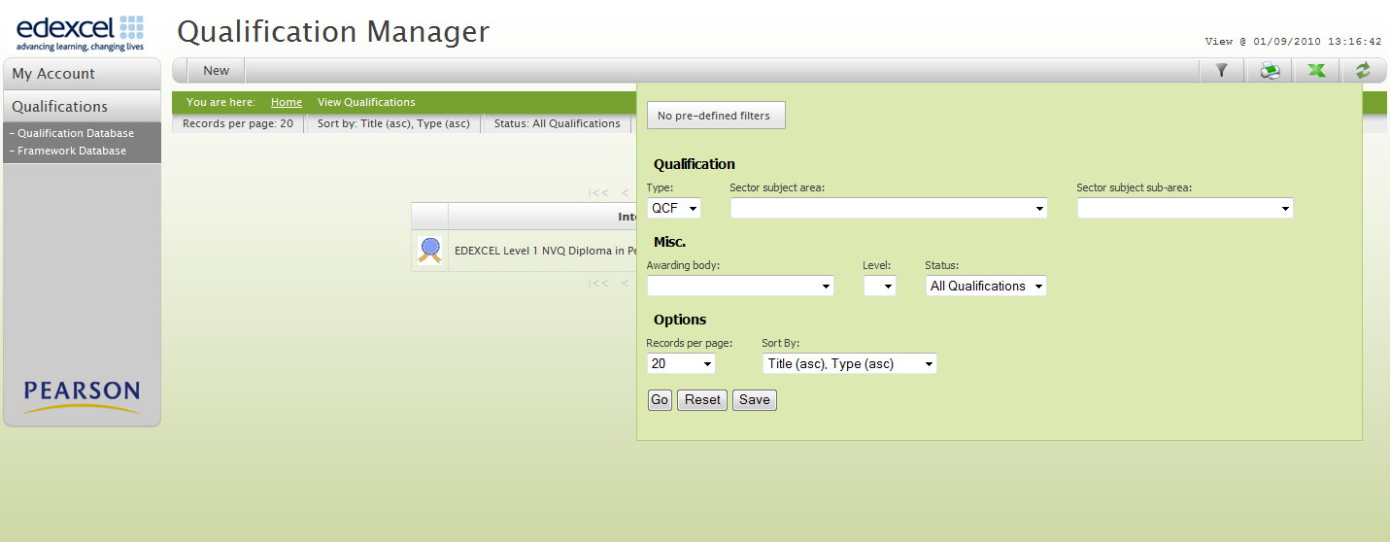
15: Apply filters for selecting qualification groups

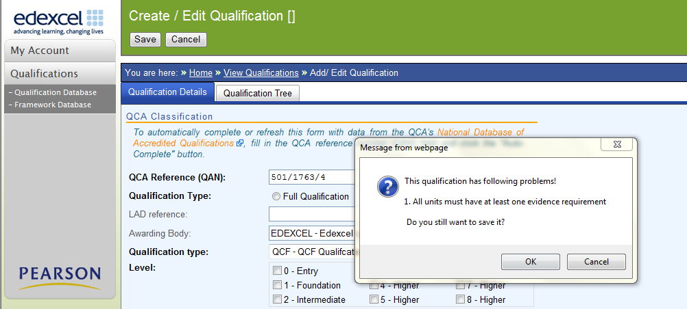
16: Contact support if this message appears during save

How to recognise and report import issues
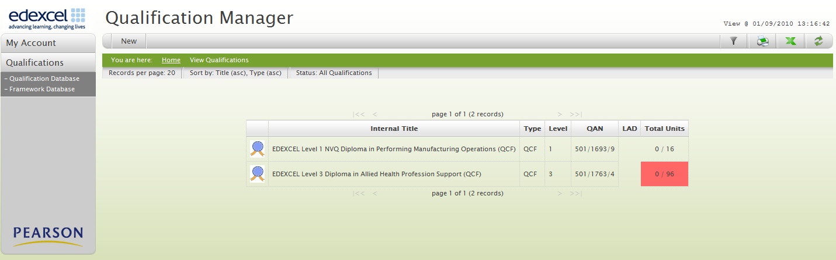
17: Contact support if this flag appears in the qualification list

Edit qualifications
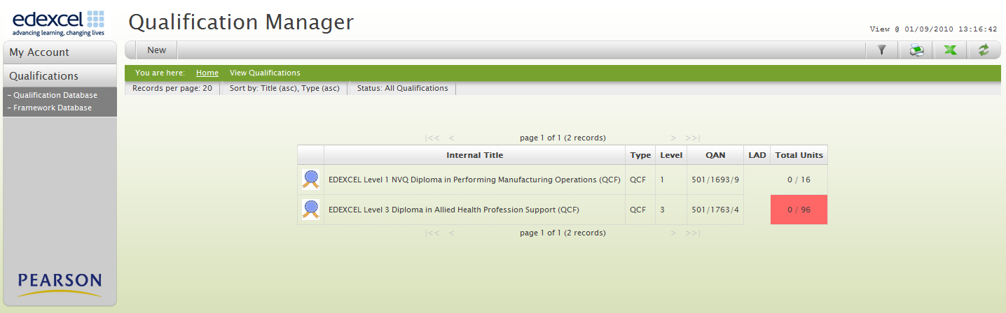
18: Select qualification to edit

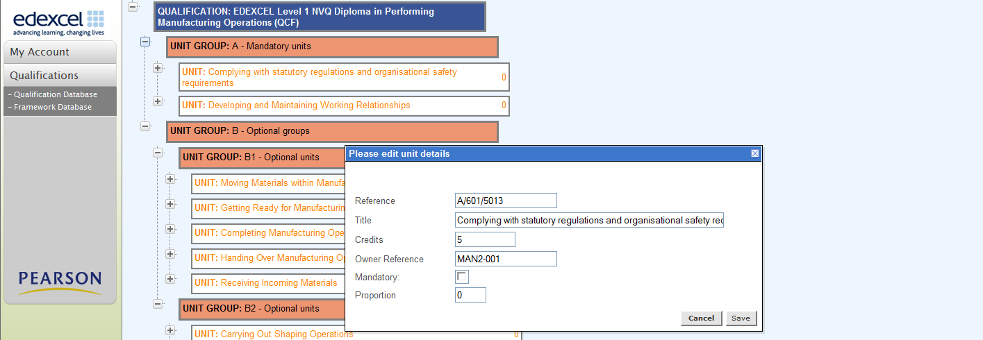
19: Tick mandatory or optional

20: Add proportion
21: Save

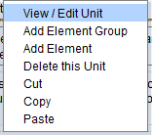
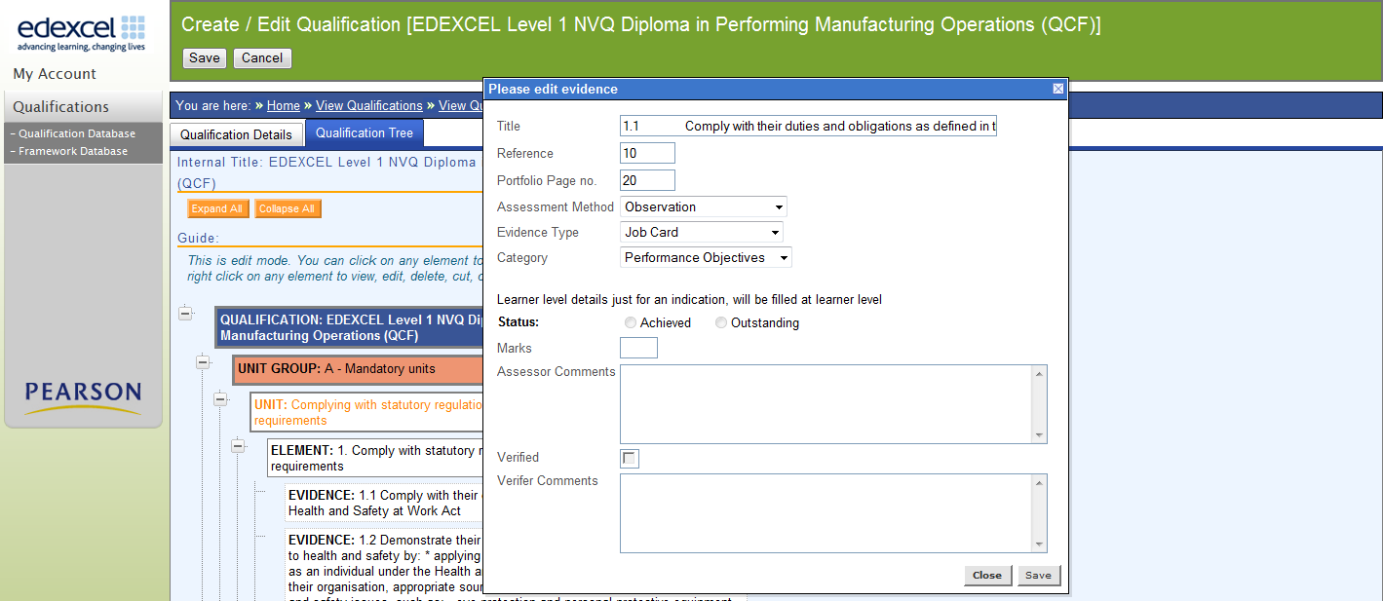
22: Right click evidence to add assessment criteria

Output of data
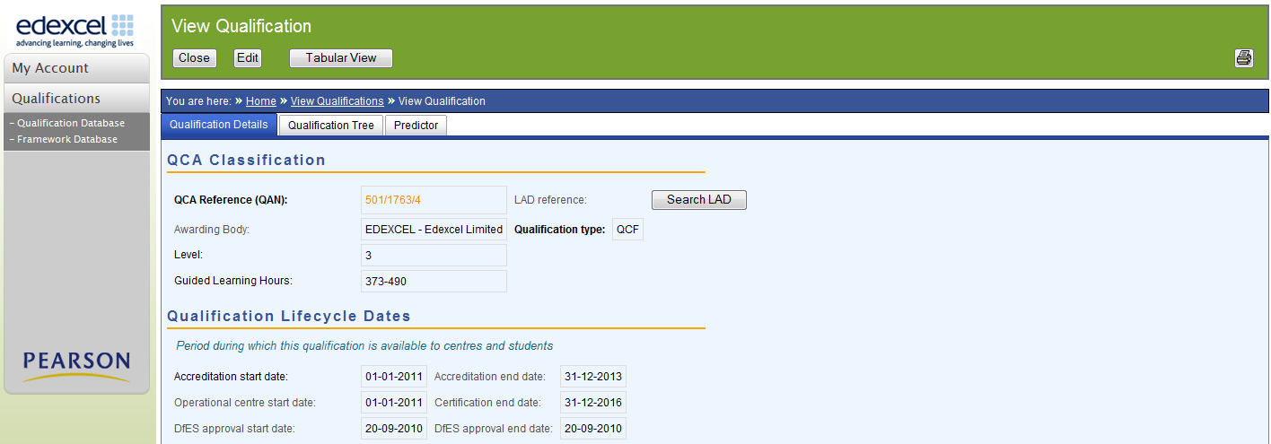
23: Click to view Tabular view

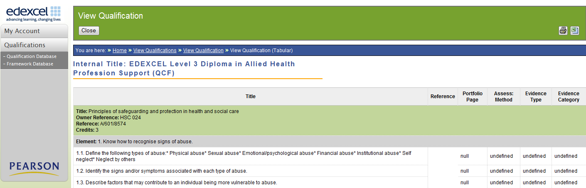
24: Confirm tabular view detail

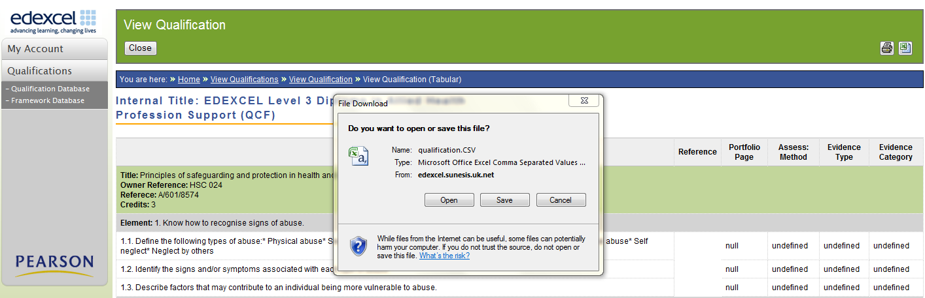
25: Click print to copy to excel spreadsheet

26: Click open or save to output spreadsheet

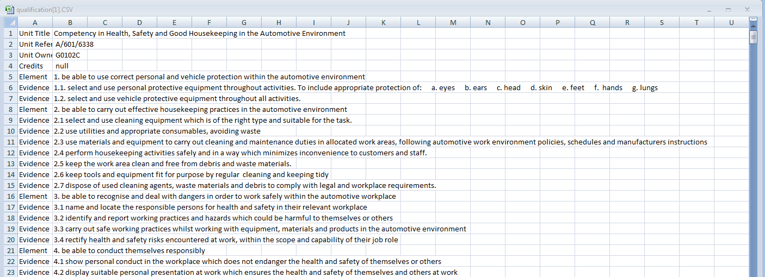
27: Export to csv file

Useful additions:
Learning Aim Database (LAD)
28: Link to qualification details in LAD.

Funding predictor enables you to calculate the amount of funding available for each qualification
29: Click to view Predictor

